Lab 13
Intro to NextGen Firewalls
Cisco FirePower
Objective:
The purpose of this lab is for the student to understand configuration and implement URL Filtering rules using Cisco Firepower
Diagram:

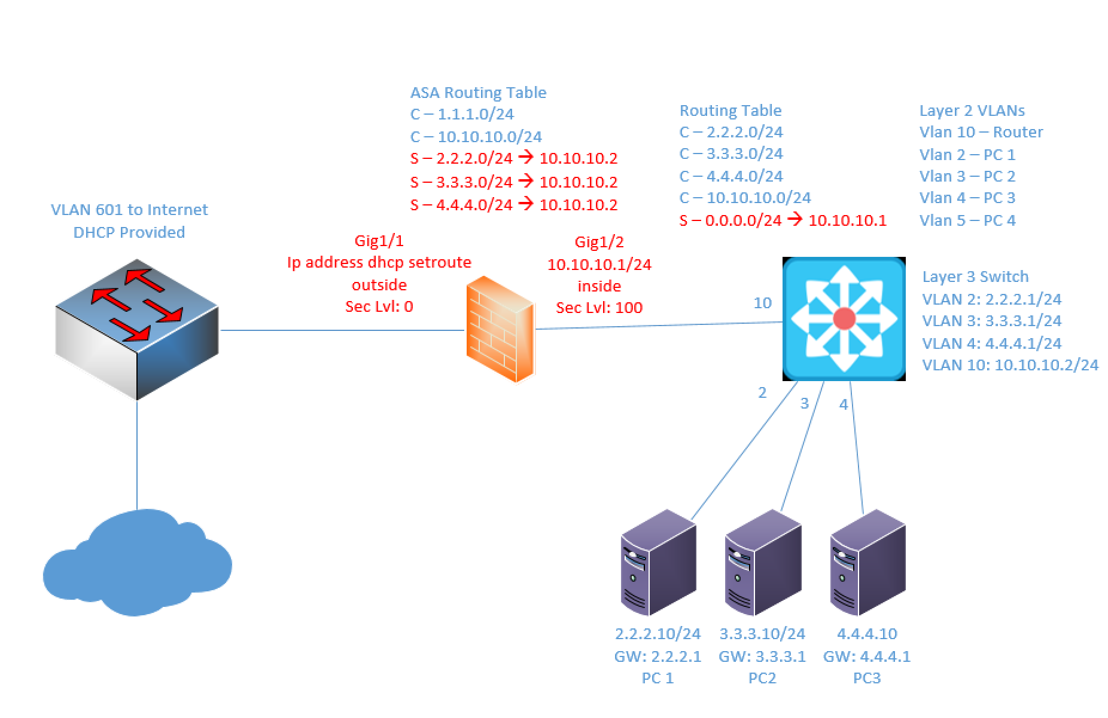

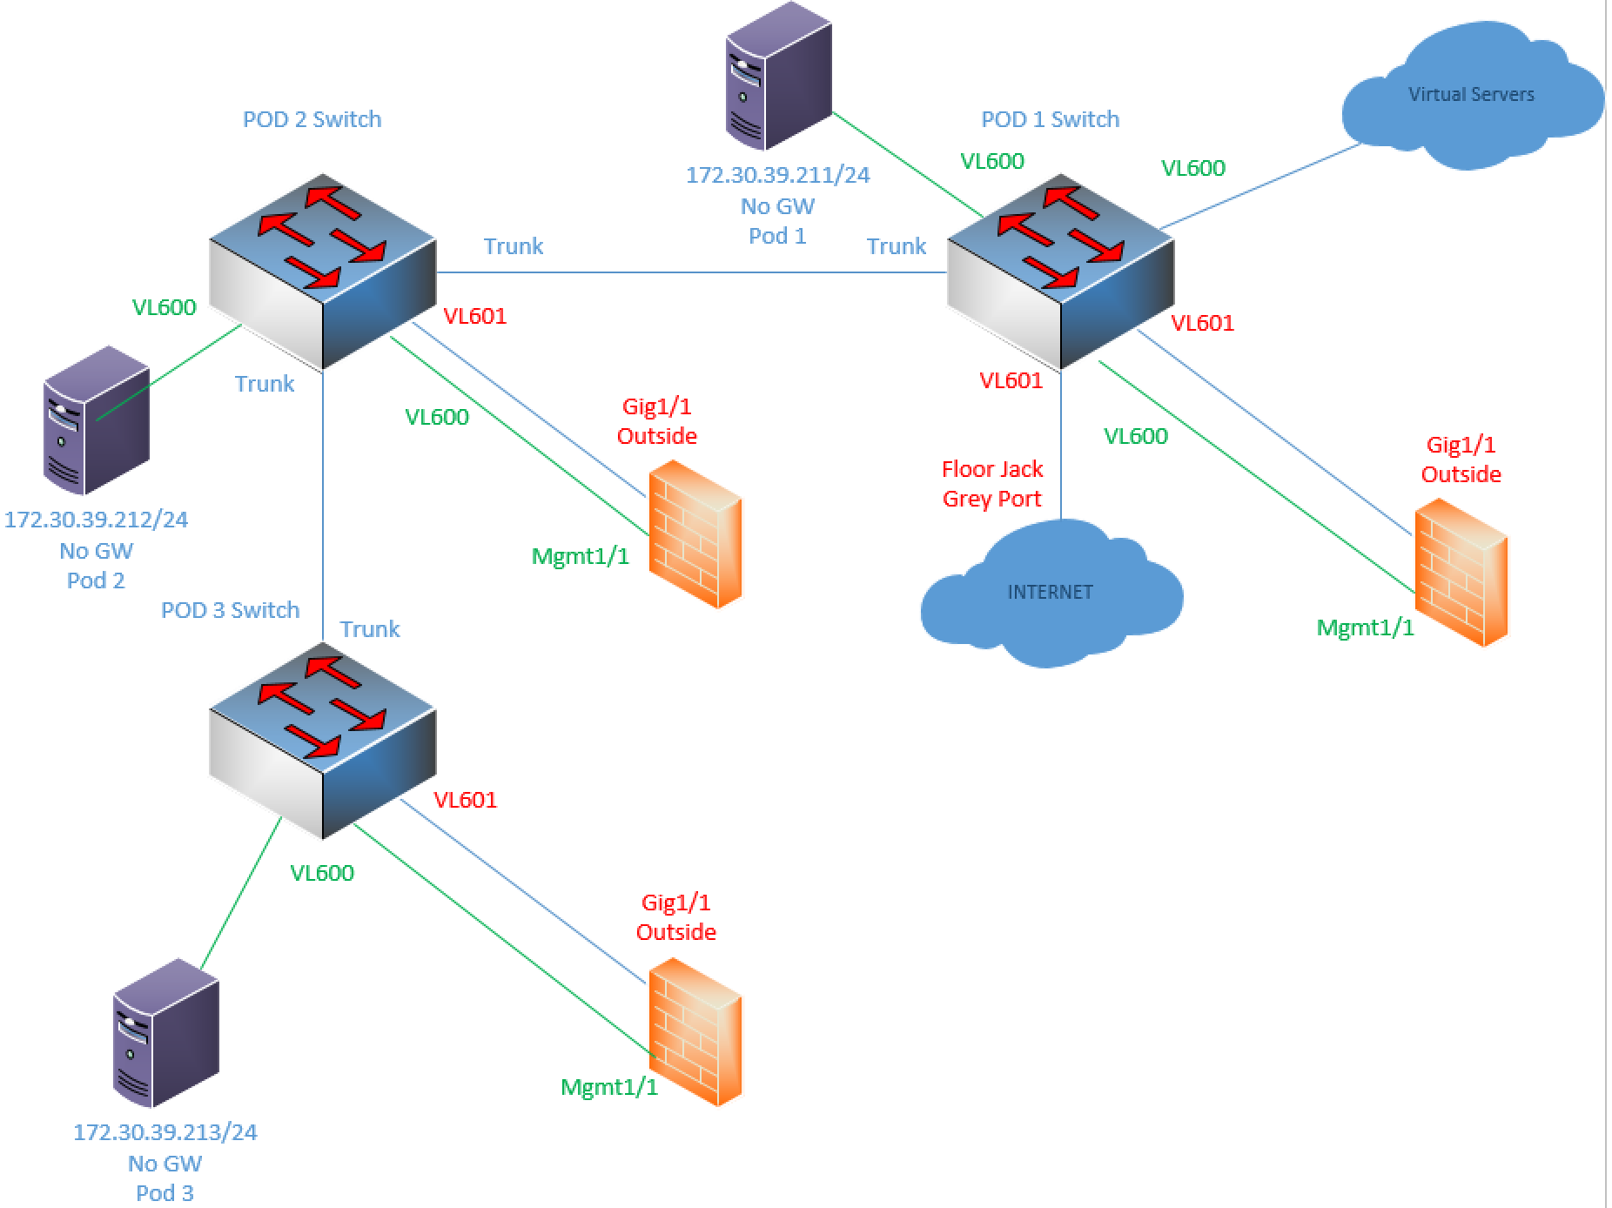
Components:
4 – PCs
1 – Cisco 5516X ASA
1 – Cisco 3650 L3 Switch
1 – Cisco 3650 L2 Switch

Useful commands for this lab
ASA Interface and Routing Config
interface gig 1/1
nameif outside
ip address dhcp setroute
no shutdown
security-level 0

interface gig 1/2
nameif inside
ip address 10.10.10.1 255.255.255.0
no shutdown
security-level 0

route inside 2.2.2.0 255.255.255.0 10.10.10.2
route inside 3.3.3.0 255.255.255.0 10.10.10.2
route inside 4.4.4.0 255.255.255.0 10.10.10.2

object network obj-any
subnet 0.0.0.0 0.0.0.0
nat (inside,outside) dynamic interface

Redirect Traffic to FirePower Module
class global-class
match any

policy-map global_policy
class global-class
sfr fail-open

Procedure:
- Connect all PCs, switches and routers as shown in the diagram above.
- Use the configuration above on the ASA
- If you want/need help with the L3 switch, let me know. I want more time spent in the FMC GUI than setting up the physical network.
- Connect to the GUI on your management PC using https://172.30.39.200. I will set up the connection to this network since it’s on the virtual servers in the rack. We’re all using the same Management server, but I set up different users for each pod. Please do not edit any other group’s policies. Pod 1 is by the door. Pod 3 is by the closet. Pod 2 is diagonal from where I sit.
  - Pod1 credentials: netc230pod1\Netcom339
  - Pod2 credentials netc230pod2\Netcom339
  - Pod2 credentials netc230pod3\Netcom339

- Since we covered URL filtering this week in lecture, that’s what we’ll concentrate on for this lab. Browse to your Access control policy that was created last week for your pod. Go to Policies, Access-Control, Access-Control
- Click on the pencil next to your pod’s policy. You can delete the rules from the previous lab.
- First, let’s create a rule that blocks the following categories for all networks, users, zones, etc.
  - Adult
  - All Drug Related
  - All Spam related
  - All violence, weapon, alcohol and gambling.
  - Dating sites
  - Social Media
  - Name the Rule “NETC290 Category Block Rule”
  - Choose the Block with Reset Action
  - Click the Logging tab and enable logging at beginning and end
  - Click Add to finish the rule
  - Screen shot your categories and paste below
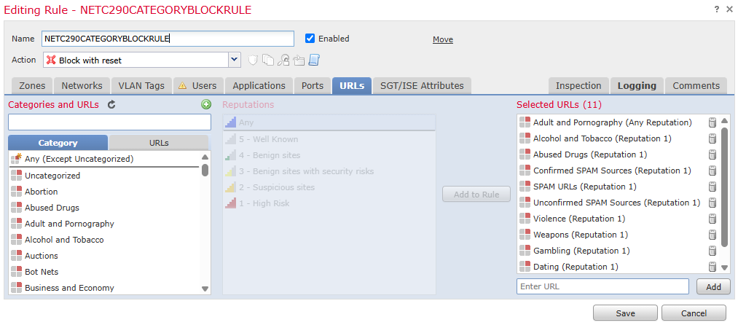
- Let’s create another rule that permits everything and place it at the bottom of the list.
- Click the Deploy button after your rule is complete. Watch the status of your pod’s device by clicking on the task button at the top.

- Once this is done, try a few sites (non-offensive … don’t get us in trouble the first time we do this lab). Try gambling.com, twitter.com, match.com, nra.org. Paste the block page below for one of your sites. Try a few, but you don’t have to include several screenshots since they’re all the same. bestbuy.com and amazon.com should work.
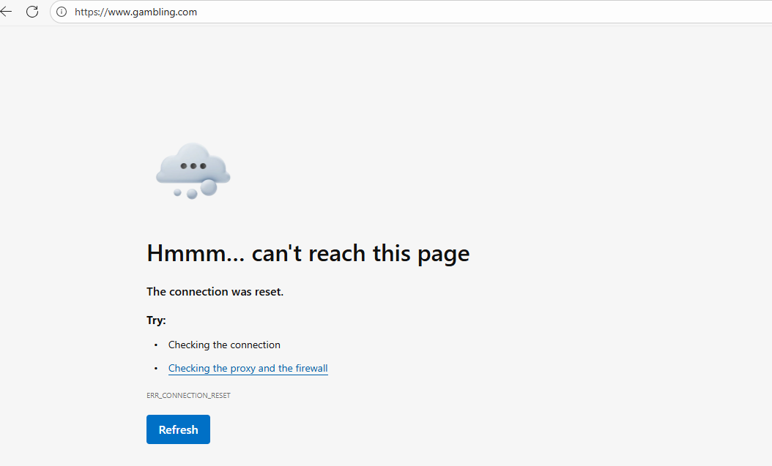
- Next we’ll set up some exceptions to these rules. Create a new rule called “Allow 2-Network to Social Media”

  - For the source network, enter 2.2.2.0/24
  - Under URL, add the social media category
  - Click the logging tab and enable logging for beginning and end.
  - Choose the Allow action.
  - Click the Add button.
  - Click your new rule and drag it above the category block rule.
  - Click Deploy once you’re back to the full policy.
  - Monitor the progress of your deployment. Once it’s done try to access twitter and Facebook from the 2.2.2.10 PC.
  - Try from the 3.3.3.10 PC. This PC should still fail to access the site.
- Next Click on Analysis, Connections, Events.
- Look through the logs and find your allows from 2.2.2.10 and blocks from 3.3.3.10. Screen shot both and paste below:
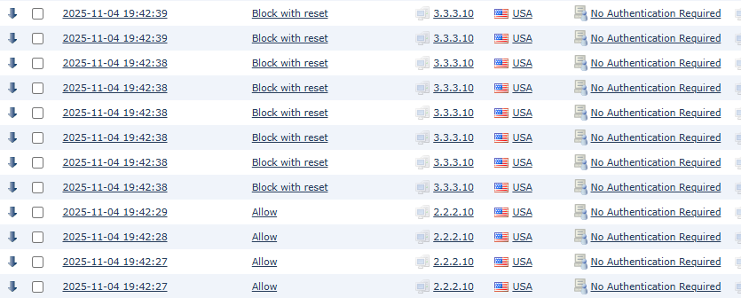
- Return to the Access Policy. Let’s create a new rule with the following options:
  - Name: “NETC290 Blacklist”
  - Action: Drop with Reset
  - Logging: Beginning and End
  - Networks, Zones, Users: any
  - URLs:
    - www.bestbuy.com
    - www.zulily.com
  - Placement: Top of the list.
- Create another rule with the following options:
  - Name: “NETC290 Whitelist”
  - Action: Allow
  - Logging: Beginning and End
  - Networks, Zones, Users: any
  - URLs:
    - nra.org
    - liquor.com
- Deploy these new rules. Monitor your rule deployment. once it’s done, verify all PCs can access the two sites in the whitelist. Verify all PCs are blocked from the sites in your blacklist.
  - Screen shot the final rule list and paste below:
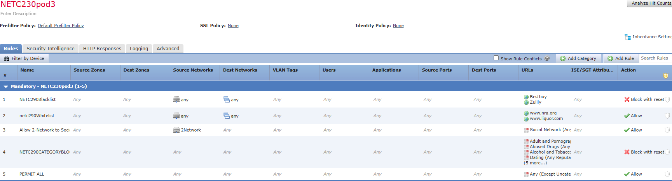
- Go back to Analysis, Connection and Events and find your traffic that was allowed and blocked. Paste a screenshot below:
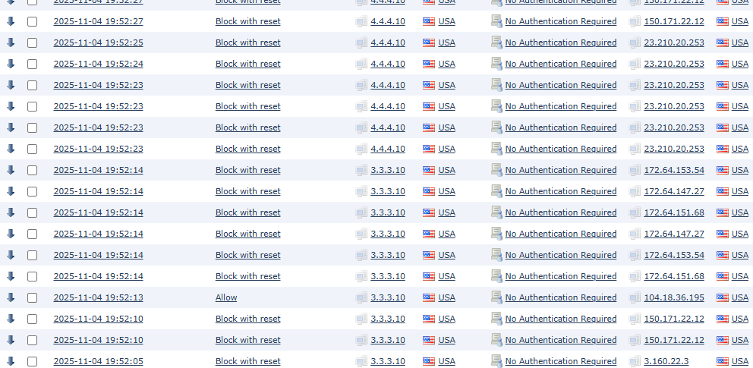
- Draw the lab diagram below (PCs, firewall and switch connections) Label the IP addresses, subnet masks, and gateways used by each device. Label all components, including your FMC and FPMs (manager and module).

